II. Methodology
A. Hardware Architecture and Power Management
The physical architecture of the proposed water quality monitoring node is designed for autonomy, durability, and low power consumption. The core processing unit is an ESP32 microcontroller, selected for its integrated Wi-Fi capabilities and efficient power management. To ensure reliable connections and modularity, the ESP32 is mounted on a custom-designed PCB docking board.
Power management is a critical component of this autonomous system. The node is powered by a 4-cell battery pack, which is continuously recharged by a solar panel. An onboard solar charge controller, coupled with an MT3608 boost converter module, regulates the incoming solar energy to safely charge the batteries even under predominantly cloudy weather conditions. To actively track the energy status, a voltage divider network is integrated into the docking board, allowing the ESP32’s Analog-to-Digital Converter (ADC) to safely read and map the battery voltage levels.
For environmental data acquisition, the system incorporates two primary sensors. Water temperature is measured using a waterproof metal-tipped probe, ensuring accurate readings without the risk of corrosion. Turbidity is monitored using a commercially available analog turbidity sensor module. To ensure strict water isolation and resistance against continuous underwater submersion in aquaculture environments, the upper wire connections of the off-the-shelf sensor were reinforced and sealed with industrial silicone. This careful hardware integration ensures that the node can operate continuously in harsh environments without manual intervention.

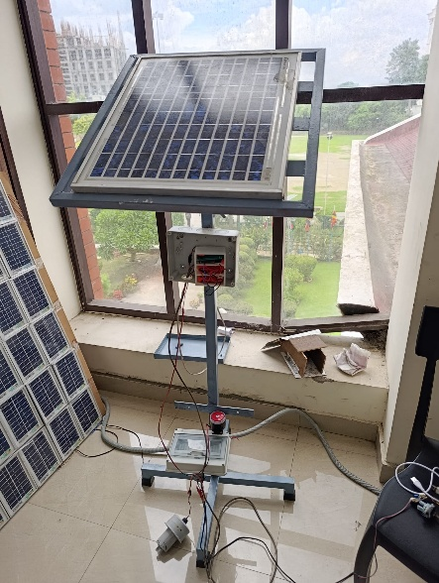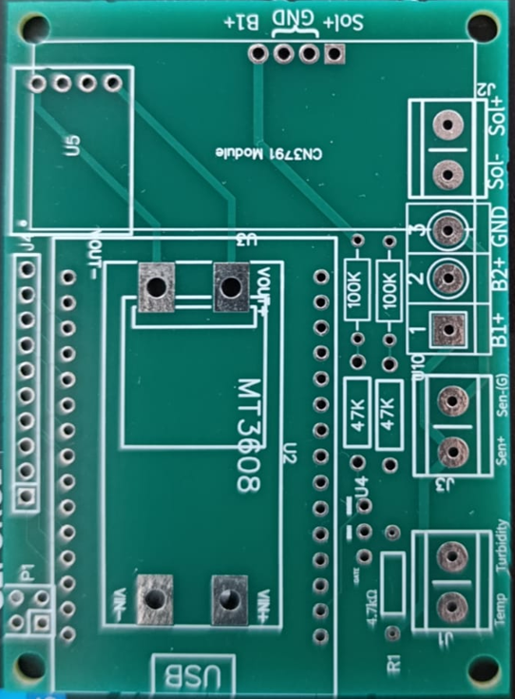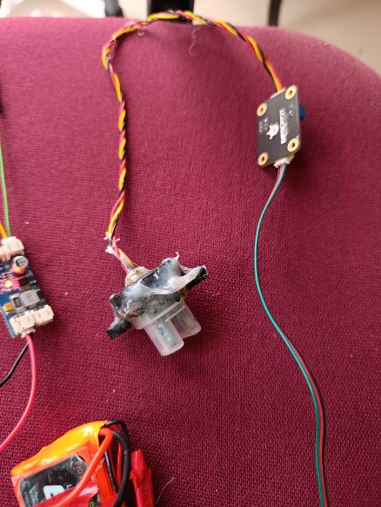
Fig. 1. Hardware components of the proposed system: (a) Solar panel and structural setup, (b) Custom-designed docking PCB, (c) Analog turbidity sensor reinforced with industrial silicone.

B. Software Design and Data Acquisition
The software architecture of the ESP32 node is developed to acquire, process, and transmit sensor data efficiently. The microcontroller is programmed to periodically sample analog data from the turbidity sensor and the battery voltage divider network. For water temperature acquisition, the system utilizes a digital communication protocol to interface with the metal-tipped probe, ensuring high-precision readings. Once the raw sensor data is acquired, the ESP32 processes these values, applying calibration factors to convert analog readings into meaningful metrics (e.g., actual voltage levels and turbidity percentages). To maintain system stability, the software includes timing routines that manage the frequency of sensor readings and Wi-Fi data transmissions.

C. Cloud Integration and IoT Framework
To enable remote monitoring, the processed data is transmitted via the ESP32’s built-in Wi-Fi module to the Thinger.io IoT platform. A custom dashboard was developed on Thinger.io to provide real-time visualization of critical parameters, including water temperature, turbidity levels, and battery status. This cloud integration allows fish farmers to access live data seamlessly through web or mobile interfaces. Furthermore, the system architecture incorporates Sinric Pro to bridge the ESP32 with smart home ecosystems. This integration enables voice-controlled interactions via Amazon Alexa, allowing users to query the current status of the aquaculture environment effortlessly.

